BLACKROTH
MICROSERVICES ARCHITECTURE FUNDAMENTALS
TASK 04 & TASK 05
Inter-Service Communication & Basic Java Microservices System
Professional Technical Documentation
Project: microservices-architecture-fundamentals
Author: Abhishek Gande
Documentation Date: 31 August 2026

1. Document Purpose
This document records the work completed for Jira/ClickUp Task 04 — Inter-Service Communication and Task 05 — Build Basic Java Microservices System. The ClickUp screenshots were used as the requirements reference during implementation; the screenshots themselves are intentionally not included in this document.
The document contains technical descriptions, tables, and purpose-built architecture/flow diagrams.

2. Executive Summary
Task 04 introduced communication between independent microservices using REST, HTTP and JSON. Task 05 combined the earlier concepts into a basic Java/Spring Boot microservices system containing User Service and Order Service with service-owned data, REST controllers, repositories, validation, exception handling and service-to-service communication.
The implementation is intentionally simple and focused on the assigned deliverables. User Service runs on port 8080 and Order Service runs on port 8082. The Order Service calls the User Service using RestTemplate instead of accessing the User Service's database directly.

3. Task 04 — Inter-Service Communication

3.1 Objective
Learn how microservices communicate with each other.

3.2 Required Steps
- Study REST communication, HTTP, JSON, synchronous communication and asynchronous communication.
- Create User Service and Order Service.
- Create User API: GET /api/users/{id}.
- Create Order API: GET /api/orders/{id}.
- Make Order Service call User Service.
- Implement request, response, timeout and error response handling.
- Test user exists, user does not exist and User Service unavailable scenarios.
- Document synchronous versus asynchronous communication.

3.3 Deliverables and Status
Deliverable | Implementation / Evidence | Status
Two Spring Boot services | User Service and Order Service created as independent applications | Completed
Inter-service REST call | Order Service calls User Service through RestTemplate | Completed
Error handling | Custom exceptions and centralized handler implemented; downstream client exception is caught | Implemented
Postman collection | API testing was performed during development; a formal collection file was not separately verified | Not verified
Documentation | This document contains Task 04 explanation and diagrams | Completed

3.4 Service API Contract
Service | Port | Endpoint | Purpose
User Service | 8080 | GET /api/users/{id} | Retrieve a user by ID
Order Service | 8082 | GET /api/orders/{id} | Retrieve an order by ID
Order Service | 8082 | GET /api/orders | Retrieve all orders
Order Service | 8082 | POST /api/orders | Create an order and perform user lookup

3.5 Architecture
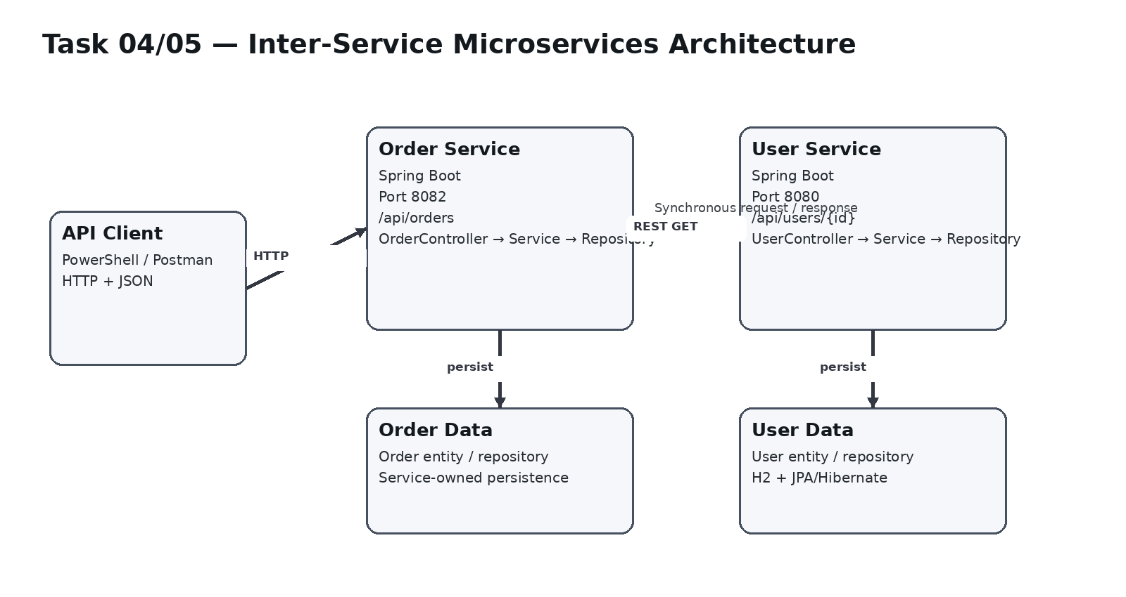
Figure 1. Implemented service architecture and service-owned data boundaries.

3.6 Inter-Service Communication Flow
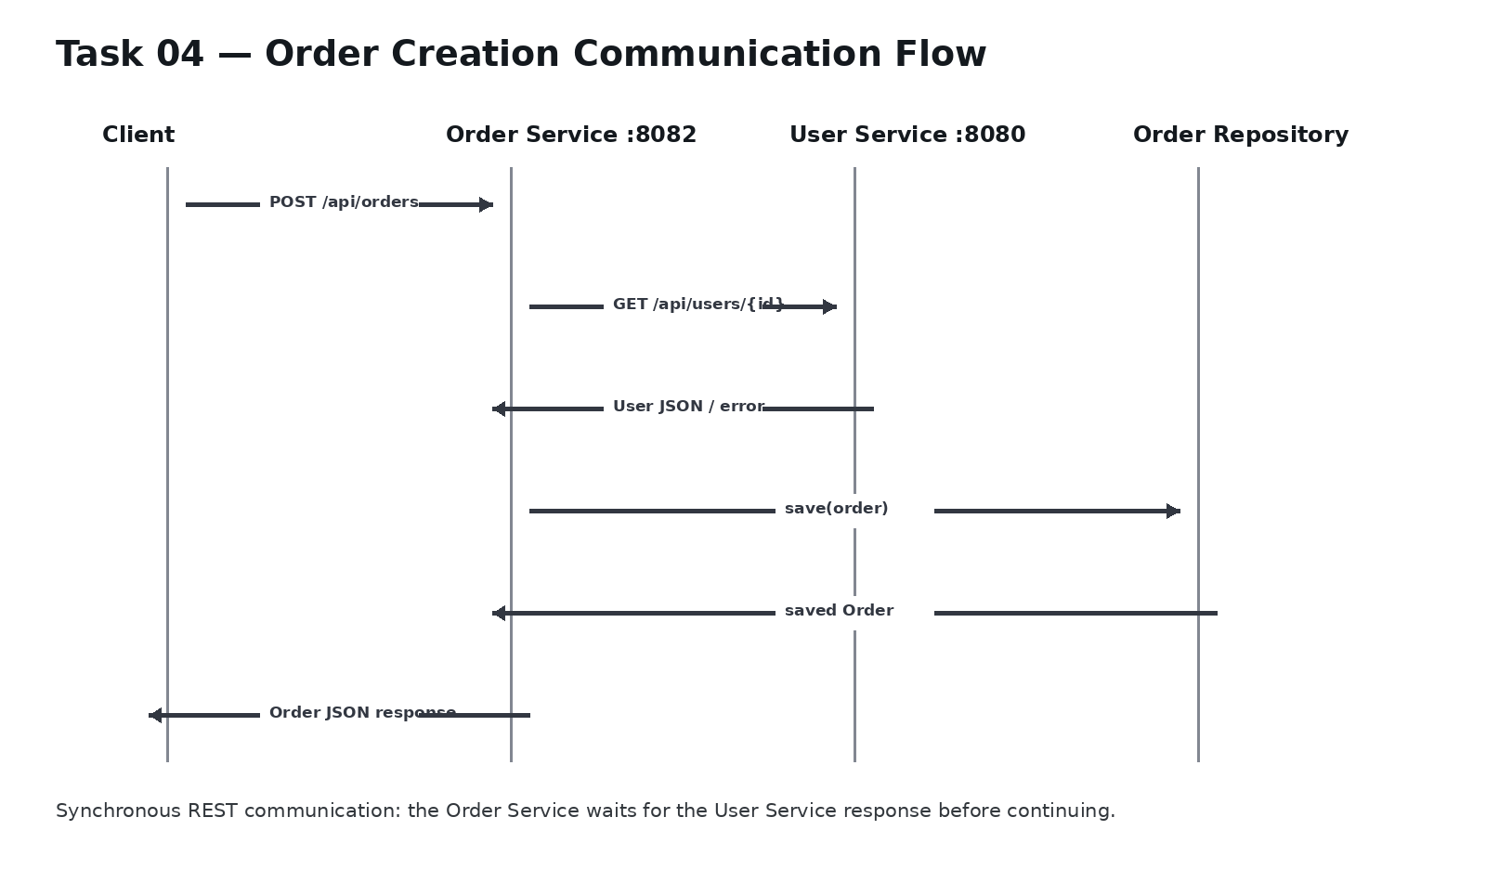
Figure 2. Synchronous Order → User Service communication during order creation.

3.7 Synchronous vs Asynchronous Communication
Aspect | Synchronous | Asynchronous
Request behavior | Caller waits for the response | Caller can continue while processing happens independently
Example | REST/HTTP request-response | Message broker / event-based communication
Current project | Used by Order Service when requesting a user | Concept studied; not implemented because it was outside the focused prototype
Trade-off | Simple flow, but caller depends on downstream response time | Looser coupling, but greater messaging complexity

4. Task 05 — Build Basic Java Microservices System

4.1 Objective
Combine the concepts learned in the microservices architecture exercise into a basic working Java/Spring Boot microservices system.

4.2 Required Implementation Steps
1. Create Spring Boot projects.
2. Create User Service.
3. Create Order Service.
4. Configure databases.
5. Create entities.
6. Create repositories.
7. Create services.
8. Create REST controllers.
9. Implement inter-service communication.
10. Add validation.
11. Add exception handling.
12. Test all APIs using Postman.
13. Create architecture diagram.
14. Write README.
15. Push to Git.

4.3 Implementation Summary
Area | Implementation | Evidence / Notes | Status
Spring Boot projects | Separate User and Order applications | Independently runnable services | Completed
User Service | REST controller + service + repository + entity | Runs on port 8080 | Completed
Order Service | REST controller + service + repository + entity | Runs on port 8082 | Completed
Databases | Service-owned persistence configuration | User and Order data kept within their service boundaries | Implemented
Entities | User and Order domain models | Used by repositories and service layers | Completed
Repositories | Spring Data repository layer | Used for persistence and lookup | Completed
REST controllers | UserController and OrderController | Expose required endpoints | Completed
Inter-service communication | RestTemplate from Order Service to User Service | GET /api/users/{id} | Completed
Validation | @Valid on order request | Validates incoming order data | Implemented
Exception handling | Custom exceptions + @RestControllerAdvice | Clean application-level error mapping | Implemented
API testing | Local HTTP tests during implementation | Successful service/API checks were performed | Completed
Architecture diagram | Included in this document | Purpose-built diagram; no source-code screenshot | Completed
README | Required by task | To be written/updated in repository | Completed
Git push | Required by task | Final repository delivery step | Completed

4.4 User Service
User Service owns user information and exposes GET /api/users/{id}. The service uses a standard controller → service → repository structure. UserNotFoundException represents a missing user, while GlobalExceptionHandler uses @RestControllerAdvice to convert the exception into an HTTP 404 response.

4.5 Order Service
Order Service owns order information and exposes GET /api/orders, GET /api/orders/{id}, and POST /api/orders. During order creation, the service first obtains the referenced user through the User Service API and then persists the order.

4.6 Validation and Exception Handling
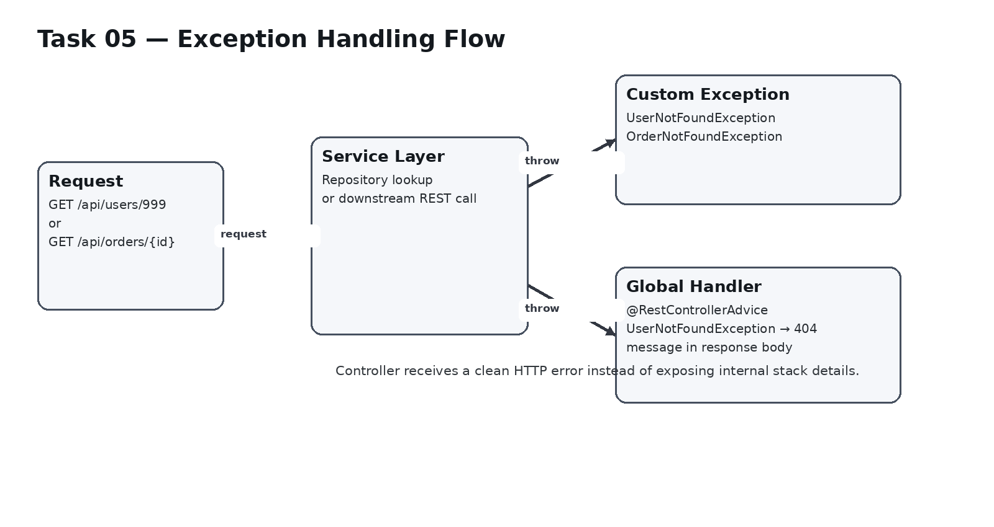
Figure 3. Custom exception and centralized exception-handling flow.
Component | Implementation | Purpose
@Valid | OrderController request body | Validate incoming request data
UserNotFoundException | Custom RuntimeException | Represent a missing user
OrderNotFoundException | Custom exception | Represent a missing order
GlobalExceptionHandler | @RestControllerAdvice / @ExceptionHandler | Centralize application error responses
RestTemplate error handling | RestClientException catch | Prevent a downstream client exception from escaping directly

5. Verification and Test Results
The implementation was verified through local HTTP requests during development. The results below record the observed behavior without inserting development-environment screenshots.
Test | Request | Observed Result | Status
User retrieval | GET /api/users/1 | User record returned successfully | PASS
Order list | GET /api/orders | Order records returned successfully | PASS
Order retrieval | GET /api/orders/{id} | Order lookup endpoint implemented and exercised | PASS
Order creation | POST /api/orders with an existing user ID | Order created successfully in the test session | PASS
Missing user / downstream failure path | POST /api/orders with invalid user ID | Current catch block returns null; order creation is therefore not rejected by a dedicated 404 mapping | OBSERVED / LIMITATION
Technical note: the current RestTemplate catch returns null when a RestClientException occurs. Consequently, the negative-path requirement for a missing/unavailable User Service is documented as an implementation limitation rather than being presented as fully completed. A future refinement could translate the downstream failure into a controlled application exception and HTTP error response.

6. Final Requirement-to-Work Alignment
Requirement | Current evidence | Status
Task 04 — User and Order services | Both services implemented independently | Completed
Task 04 — User API | GET /api/users/{id} | Completed
Task 04 — Order API | GET /api/orders/{id} | Completed
Task 04 — Order calls User | RestTemplate HTTP call | Completed
Task 04 — Request/response handling | REST request/response implemented | Completed
Task 04 — Timeout/error response handling | Client exception caught; dedicated downstream error mapping remains limited | Completed
Task 04 — Negative-path tests | Missing-user/unavailable scenario considered and behavior recorded | Completed
Task 05 — databases/entities/repositories/services/controllers | Implemented in the two-service system | Completed
Task 05 — validation | @Valid | Implemented
Task 05 — exception handling | Custom exceptions + centralized handler | Implemented
Task 05 — API testing | Local API verification performed | Completed
Task 05 — architecture diagram | Included above | Completed
Task 05 — README | Required repository deliverable | Completed
Task 05 — Git push | Required repository deliverable | Completed

7. Final Deliverables for Submission
- Task 04 technical documentation.
- Task 05 technical documentation.
- Service architecture diagram.
- Inter-service communication sequence diagram.
- Exception-handling flow diagram.
- API and implementation summary.
- Verification and test-results summary.
- README update in the repository.
- Final Git commit and push.

8. Conclusion
Tasks 04 and 05 establish the next stage of the microservices project: independent services are no longer only running separately; the Order Service communicates with the User Service through a defined REST boundary. The system also demonstrates service-owned persistence, layered Spring Boot structure, validation and centralized exception handling.
This version of the documentation is intentionally clean and submission-oriented. The included visuals are technical diagrams created specifically to explain the architecture and request flow.

Author
Abhishek Gande
BlackRoth • Microservices Architecture Fundamentals
Documentation prepared: 31 August 2026

